PatientSelection 25-Aug-2023

## Patient Selection

This is a file to carry out statistical analysis and data visualizations for the MGI Patient Selection manuscript.

### Read in the raw data

#read in the recoded raw data file  
mgi_data <- read_excel("Master file 8_25_2023 ST.xlsx", sheet = "Master")

New names:  
* `` -> `...66`

#set counts as numeric  
mgi_data$Proband_count <- as.numeric(mgi_data$Proband_count)  
mgi_data$Positive_test_count<- as.numeric(mgi_data$Positive_test_count)  
mgi_data$Year <- as.numeric(mgi_data$Year)

### Random Effects Models and Forest Plots

#### All Studies

#Meta-Analysis of Proportion with Positive Molecular Diagnosis  
m.prop_all <- metaprop(event = Positive_test_count,  
 n = Proband_count,  
 studlab = Authors,  
 data = mgi_data %>% drop_na(Proband_count),  
 method = "GLMM",  
 sm = "PLOGIT",  
 fixed = FALSE,  
 random = TRUE,  
 method.ci = "CP",  
 title = "Diagnostic Yields")  
summary(m.prop_all)

Review: Diagnostic Yields  
  
 proportion 95%-CI  
Gilissen et al 0.4200 [0.2819; 0.5679]  
Soden et al 0.7143 [0.4782; 0.8872]  
Bloss et al 0.1765 [0.0380; 0.4343]  
Willig et al 0.5714 [0.3935; 0.7368]  
Ellingford et al 0.5217 [0.3695; 0.6711]  
Kumar et al 0.4444 [0.1370; 0.7880]  
Mallawaarachchi et al 0.8571 [0.6733; 0.9597]  
Miller et al 0.6667 [0.0943; 0.9916]  
Stavropoulos et al 0.3400 [0.2482; 0.4415]  
Bick et al 0.3636 [0.1720; 0.5934]  
Bowling et al 0.2500 [0.1970; 0.3092]  
Cirino et al 0.3415 [0.2008; 0.5059]  
Hamdan et al 0.3198 [0.2553; 0.3898]  
van Diemen et al 0.3043 [0.1321; 0.5292]  
Yuen et al 0.1118 [0.0985; 0.1262]  
Alfares et al 0.0926 [0.0453; 0.1637]  
Bagnall et al 0.2414 [0.1387; 0.3717]  
Costain et al 0.1094 [0.0451; 0.2125]  
Farnaes et al 0.4286 [0.2772; 0.5904]  
Hauser et al 0.0588 [0.0072; 0.1968]  
Lionel et al 0.4078 [0.3120; 0.5090]  
Mestek-Boukhibar et al 0.4167 [0.2211; 0.6336]  
Petrikin et al (NSIGHT1) 0.3243 [0.1801; 0.4979]  
Ostrander et al 0.8571 [0.5719; 0.9822]  
Splinter et al 0.1879 [0.1314; 0.2560]  
Alankarage et al 0.3093 [0.2193; 0.4112]  
French et al 0.2051 [0.1508; 0.2687]  
Gross et al 0.1519 [0.0810; 0.2503]  
Hull et al 0.6000 [0.1466; 0.9473]  
Kang et al 0.3333 [0.0084; 0.9057]  
Kumar et al 0.1171 [0.0639; 0.1919]  
Lee et al 0.1892 [0.1075; 0.2970]  
Liu et al 0.6250 [0.3543; 0.8480]  
Minoche et al 0.5714 [0.4096; 0.7228]  
Sanford et al 0.4474 [0.2862; 0.6170]  
Schluth-Bolard et al 0.4000 [0.2702; 0.5409]  
Scocchia et al 0.6833 [0.5504; 0.7974]  
Shashi et al 0.2778 [0.0969; 0.5348]  
Thiffault et al 0.2375 [0.1495; 0.3458]  
Al-Hassnan et al 0.5366 [0.4658; 0.6063]  
Aryan et al 0.2000 [0.1003; 0.3372]  
Costain et al 0.3061 [0.1825; 0.4542]  
Dahl et al 0.1379 [0.0389; 0.3166]  
Helman et al 0.3415 [0.2008; 0.5059]  
Jackson et al 0.3609 [0.3097; 0.4147]  
Kingsmore et al 0.2373 [0.1638; 0.3244]  
Reuter et al 0.1261 [0.0707; 0.2026]  
Riley et al 0.5500 [0.3849; 0.7074]  
Vanderver et al 0.5938 [0.4064; 0.7630]  
Wang et al 0.4769 [0.3886; 0.5663]  
Bhatia et al 0.3333 [0.1563; 0.5532]  
Brockman et al 0.1616 [0.0953; 0.2491]  
Chan et al 0.5833 [0.2767; 0.8483]  
Dimmock et al 0.4022 [0.3307; 0.4768]  
Krantz et al 0.3136 [0.2656; 0.3647]  
Mallawaarachchi et al 0.7014 [0.6196; 0.7747]  
Maron et al 0.3274 [0.2421; 0.4221]  
Naess et al 0.5625 [0.3766; 0.7364]  
Palmer et al 0.6333 [0.4386; 0.8007]  
Schon et al 0.3188 [0.2700; 0.3709]  
Smedley et al 0.2501 [0.2321; 0.2688]  
Stranneheim et al 0.4001 [0.3831; 0.4173]  
Sweeney et al 0.4583 [0.2555; 0.6718]  
Zou et al 0.3656 [0.3128; 0.4210]  
Ewans et al 0.3421 [0.1963; 0.5135]  
Lesurf et al 0.3923 [0.3257; 0.4621]  
Lindstrand et al 0.3013 [0.2426; 0.3652]  
Palmquist et al 0.3421 [0.2371; 0.4599]  
Shoemark et al 0.1197 [0.0713; 0.1848]  
Bowling et al 0.2997 [0.2533; 0.3494]  
Wu et al 0.3663 [0.2998; 0.4368]  
  
Number of studies: k = 71  
Number of observations: o = 13913  
Number of events: e = 4214  
  
 proportion 95%-CI  
Random effects model 0.3443 [0.3012; 0.3900]  
  
Quantifying heterogeneity:  
 tau^2 = 0.6021; tau = 0.7760; I^2 = 93.0% [91.8%; 94.0%]; H = 3.77 [3.48; 4.08]  
  
Test of heterogeneity:  
 Q d.f. p-value  
 Wald 995.06 70 < 0.0001  
 LRT 1199.45 70 < 0.0001  
  
Details on meta-analytical method:  
- Random intercept logistic regression model  
- Maximum-likelihood estimator for tau^2  
- Logit transformation  
- Clopper-Pearson confidence interval for individual studies

#forest plot including all studies  
png(file = "forestplot_DY.png", width = 3500, height = 5000, res = 300)  
forest.meta(m.prop_all,   
 sortvar = DY_percent,   
 leftcols = c("Authors", "Positive_test_count", "Proband_count", "ACR_FINAL"),  
 leftlabs = c("Author", "Events", "Total", "Quality"))  
dev.off()

png   
 2

knitr::include_graphics('./forestplot_DY.png')

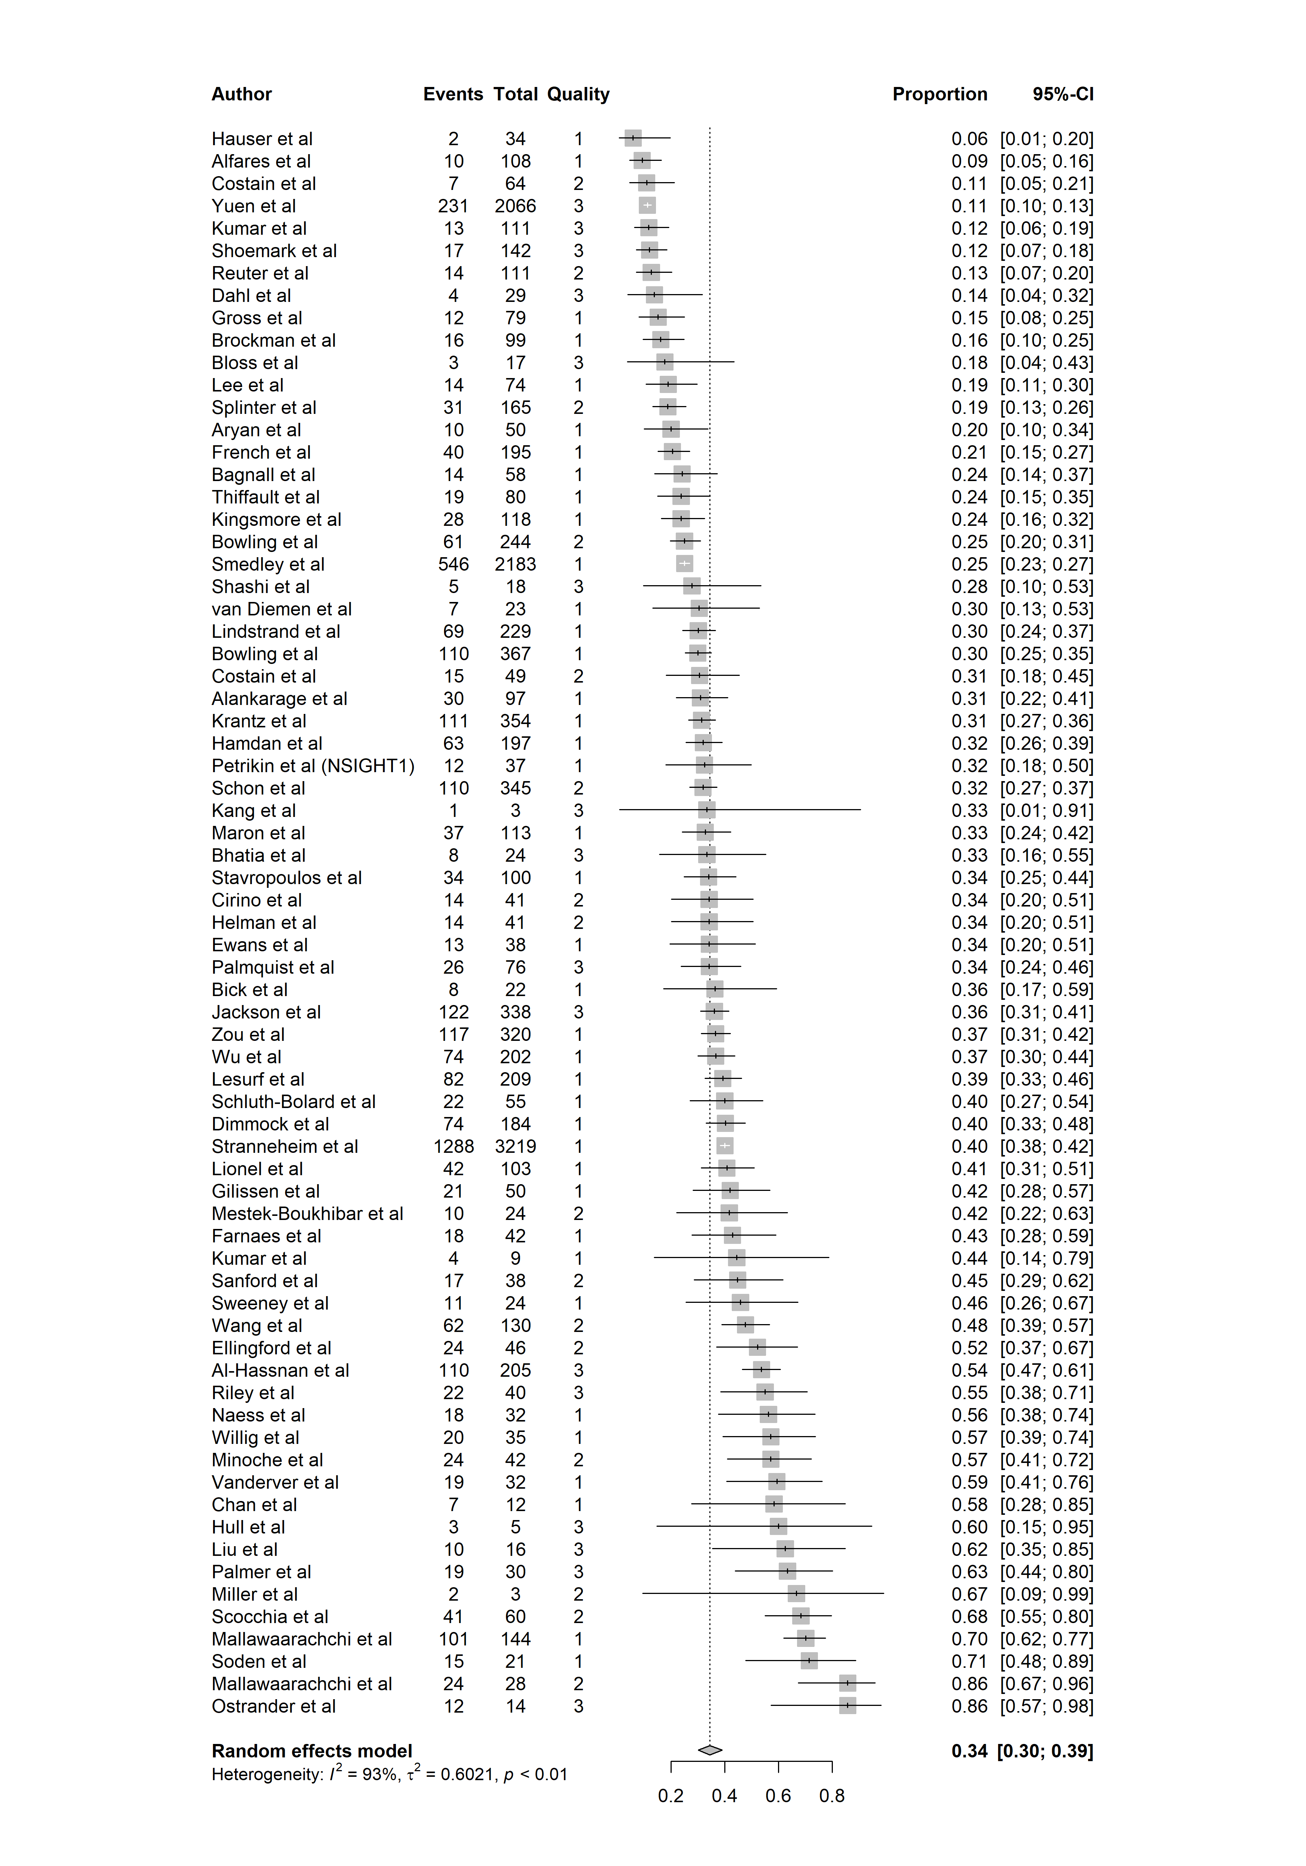

png(file = "forestplot_qual.png", width = 3500, height = 5000, res = 300)  
forest.meta(m.prop_all,   
 sortvar = ACR_FINAL,   
 leftcols = c("Authors", "Positive_test_count", "Proband_count", "ACR_FINAL"),  
 leftlabs = c("Author", "Events", "Total", "Quality"))  
dev.off()

png   
 2

knitr::include_graphics('./forestplot_qual.png')

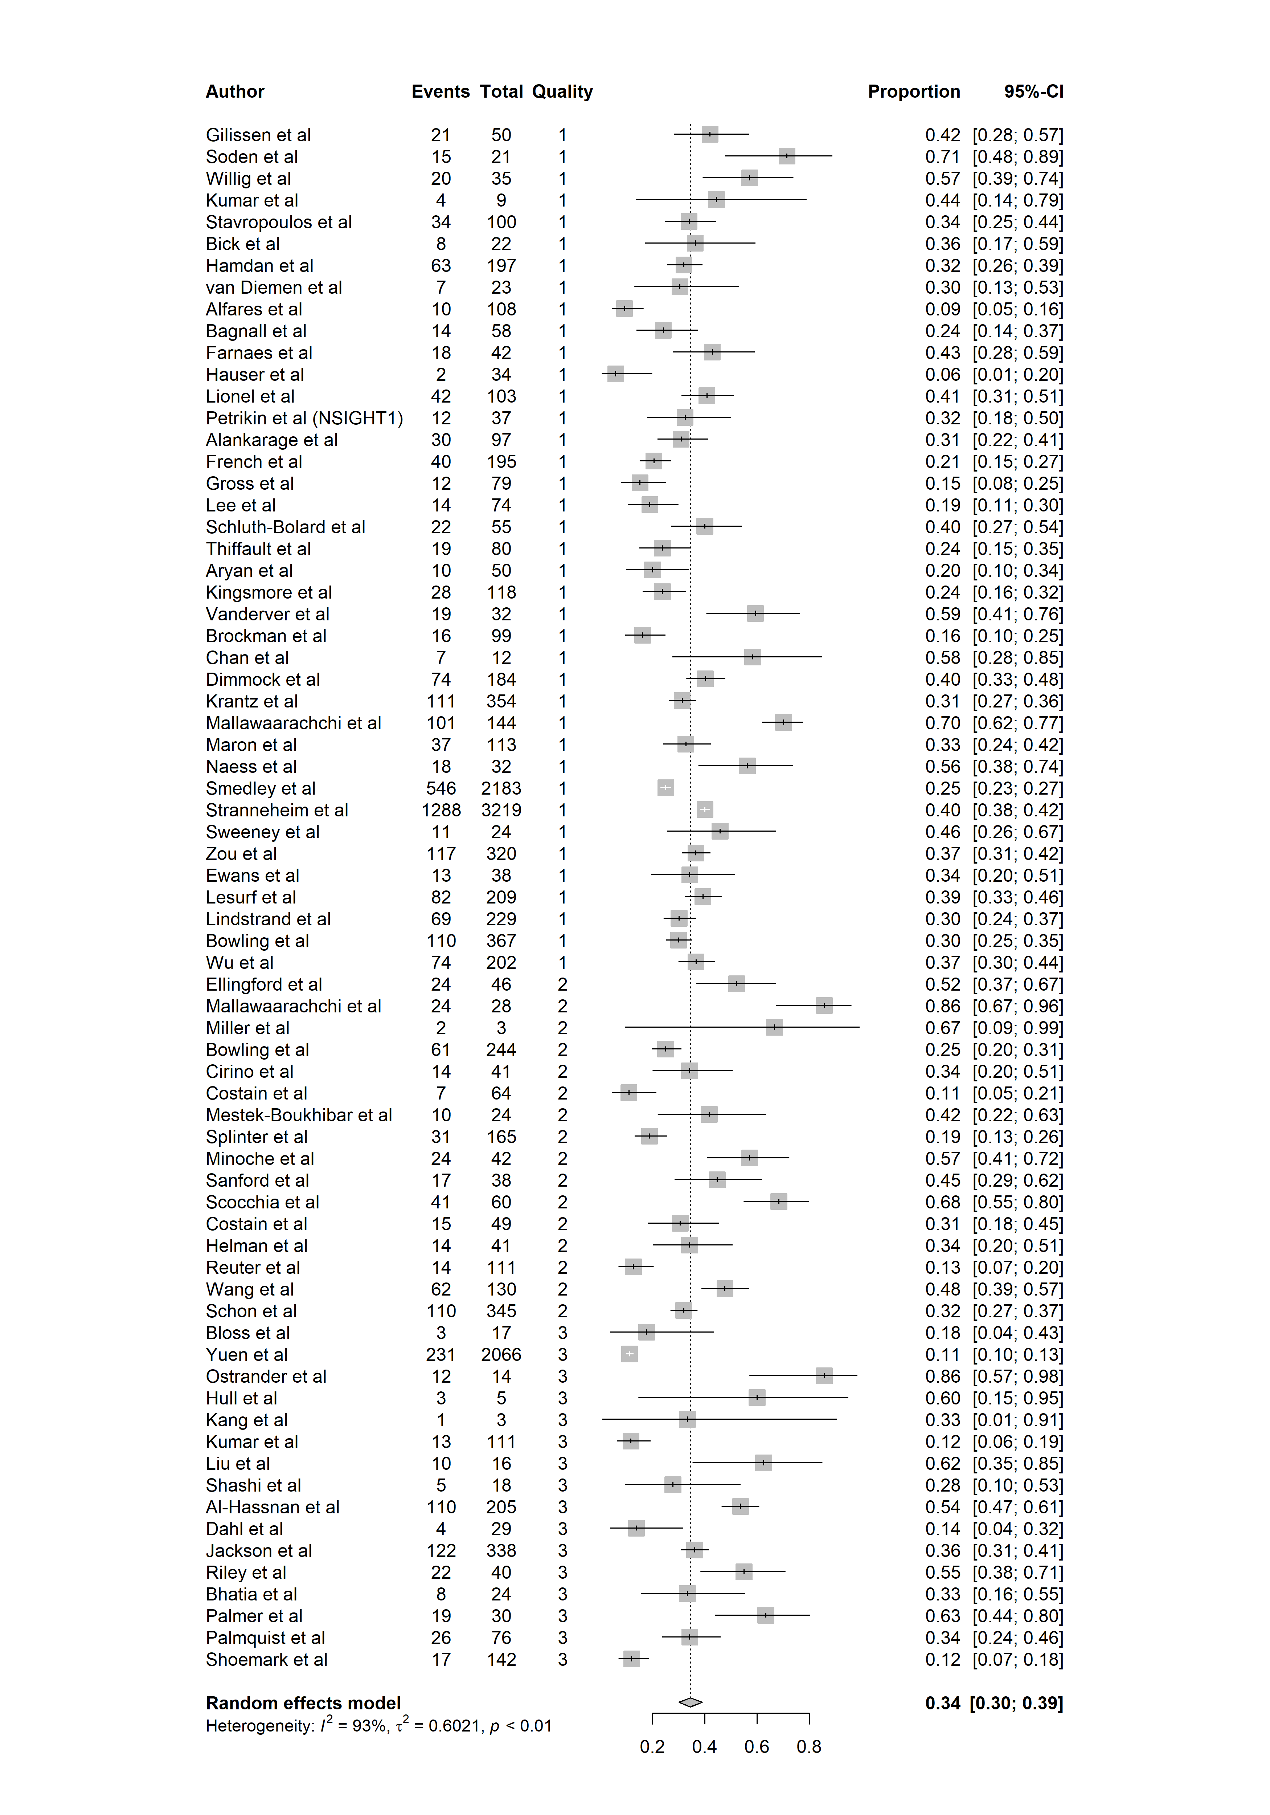

png(file = "forestplot_phen.png", width = 3500, height = 5000, res = 300)  
forest.meta(m.prop_all,   
 sortvar = Phenotype_Group,   
 leftcols = c("Authors", "Positive_test_count", "Proband_count", "Phenotype_Group"),  
 leftlabs = c("Author", "Events", "Total", "Phenotype"))  
dev.off()

png   
 2

knitr::include_graphics('./forestplot_phen.png')

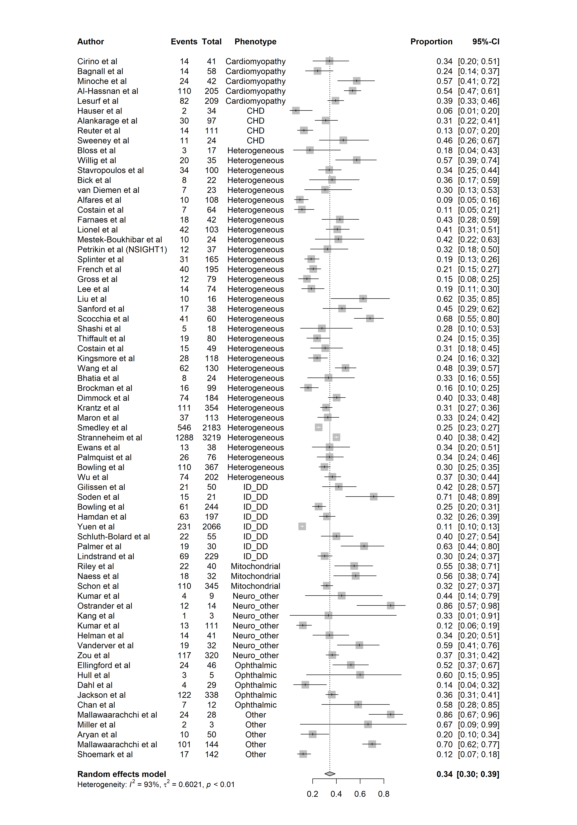

#### Heterogeneous Phenotypes

m.prop_clin_heterogeneous <- metaprop(event = Positive_test_count,  
 n = Proband_count,  
 studlab = Authors,  
 data = mgi_data %>% drop_na(Proband_count) %>%   
 filter(Phenotype_Group == "Heterogeneous"),  
 method = "GLMM",  
 sm = "PLOGIT",  
 fixed = FALSE,  
 random = TRUE,  
 method.ci = "CP",  
 title = "Diagnostic Yields")  
summary(m.prop_clin_heterogeneous)

Review: Diagnostic Yields  
  
 proportion 95%-CI  
Bloss et al 0.1765 [0.0380; 0.4343]  
Willig et al 0.5714 [0.3935; 0.7368]  
Stavropoulos et al 0.3400 [0.2482; 0.4415]  
Bick et al 0.3636 [0.1720; 0.5934]  
van Diemen et al 0.3043 [0.1321; 0.5292]  
Alfares et al 0.0926 [0.0453; 0.1637]  
Costain et al 0.1094 [0.0451; 0.2125]  
Farnaes et al 0.4286 [0.2772; 0.5904]  
Lionel et al 0.4078 [0.3120; 0.5090]  
Mestek-Boukhibar et al 0.4167 [0.2211; 0.6336]  
Petrikin et al (NSIGHT1) 0.3243 [0.1801; 0.4979]  
Splinter et al 0.1879 [0.1314; 0.2560]  
French et al 0.2051 [0.1508; 0.2687]  
Gross et al 0.1519 [0.0810; 0.2503]  
Lee et al 0.1892 [0.1075; 0.2970]  
Liu et al 0.6250 [0.3543; 0.8480]  
Sanford et al 0.4474 [0.2862; 0.6170]  
Scocchia et al 0.6833 [0.5504; 0.7974]  
Shashi et al 0.2778 [0.0969; 0.5348]  
Thiffault et al 0.2375 [0.1495; 0.3458]  
Costain et al 0.3061 [0.1825; 0.4542]  
Kingsmore et al 0.2373 [0.1638; 0.3244]  
Wang et al 0.4769 [0.3886; 0.5663]  
Bhatia et al 0.3333 [0.1563; 0.5532]  
Brockman et al 0.1616 [0.0953; 0.2491]  
Dimmock et al 0.4022 [0.3307; 0.4768]  
Krantz et al 0.3136 [0.2656; 0.3647]  
Maron et al 0.3274 [0.2421; 0.4221]  
Smedley et al 0.2501 [0.2321; 0.2688]  
Stranneheim et al 0.4001 [0.3831; 0.4173]  
Ewans et al 0.3421 [0.1963; 0.5135]  
Palmquist et al 0.3421 [0.2371; 0.4599]  
Bowling et al 0.2997 [0.2533; 0.3494]  
Wu et al 0.3663 [0.2998; 0.4368]  
  
Number of studies: k = 34  
Number of observations: o = 8456  
Number of events: e = 2768  
  
 proportion 95%-CI  
Random effects model 0.3091 [0.2649; 0.3571]  
  
Quantifying heterogeneity:  
 tau^2 = 0.3296; tau = 0.5741; I^2 = 89.1% [85.8%; 91.6%]; H = 3.03 [2.66; 3.45]  
  
Test of heterogeneity:  
 Q d.f. p-value  
 Wald 302.96 33 < 0.0001  
 LRT 335.78 33 < 0.0001  
  
Details on meta-analytical method:  
- Random intercept logistic regression model  
- Maximum-likelihood estimator for tau^2  
- Logit transformation  
- Clopper-Pearson confidence interval for individual studies

png(file = "forestplot_phen_heterogeneous.png", width = 3000, height = 2750, res = 300)  
forest.meta(m.prop_clin_heterogeneous,   
 sortvar = DY_percent,   
 leftcols = c("Authors", "Positive_test_count", "Proband_count", "ACR_FINAL"),  
 leftlabs = c("Author", "Events", "Total", "Quality"))  
dev.off()

png   
 2

knitr::include_graphics('./forestplot_phen_heterogeneous.png')

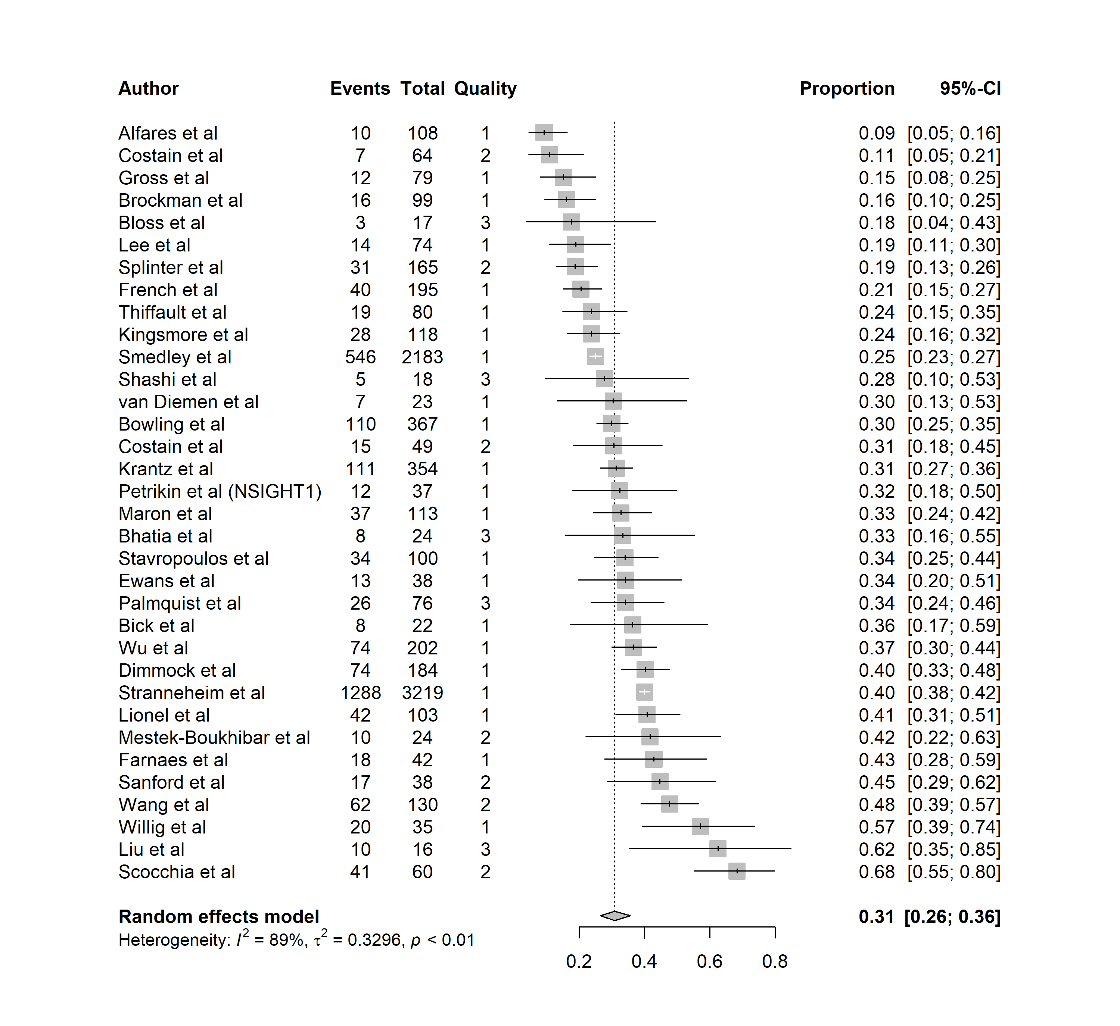

#### ID/DD/ASD/Epilepsy

m.prop_clin_ID <- metaprop(event = Positive_test_count,  
 n = Proband_count,  
 studlab = Authors,  
 data = mgi_data %>% drop_na(Proband_count) %>%   
 filter(Phenotype_Group == "ID_DD"),  
 method = "GLMM",  
 sm = "PLOGIT",  
 fixed = FALSE,  
 random = TRUE,  
 method.ci = "CP",  
 title = "Diagnostic Yields")  
summary(m.prop_clin_ID)

Review: Diagnostic Yields  
  
 proportion 95%-CI  
Gilissen et al 0.4200 [0.2819; 0.5679]  
Soden et al 0.7143 [0.4782; 0.8872]  
Bowling et al 0.2500 [0.1970; 0.3092]  
Hamdan et al 0.3198 [0.2553; 0.3898]  
Yuen et al 0.1118 [0.0985; 0.1262]  
Schluth-Bolard et al 0.4000 [0.2702; 0.5409]  
Palmer et al 0.6333 [0.4386; 0.8007]  
Lindstrand et al 0.3013 [0.2426; 0.3652]  
  
Number of studies: k = 8  
Number of observations: o = 2892  
Number of events: e = 501  
  
 proportion 95%-CI  
Random effects model 0.3600 [0.2366; 0.5052]  
  
Quantifying heterogeneity:  
 tau^2 = 0.6633; tau = 0.8144; I^2 = 96.6% [94.9%; 97.7%]; H = 5.42 [4.44; 6.61]  
  
Test of heterogeneity:  
 Q d.f. p-value  
 Wald 205.36 7 < 0.0001  
 LRT 210.70 7 < 0.0001  
  
Details on meta-analytical method:  
- Random intercept logistic regression model  
- Maximum-likelihood estimator for tau^2  
- Logit transformation  
- Clopper-Pearson confidence interval for individual studies

png(file = "forestplot_phen_ID.png", width = 3000, height = 1500, res = 300)  
forest.meta(m.prop_clin_ID,   
 sortvar = DY_percent,   
 leftcols = c("Authors", "Positive_test_count", "Proband_count", "ACR_FINAL"),  
 leftlabs = c("Author", "Events", "Total", "Quality"))  
dev.off()

png   
 2

knitr::include_graphics('./forestplot_phen_ID.png')

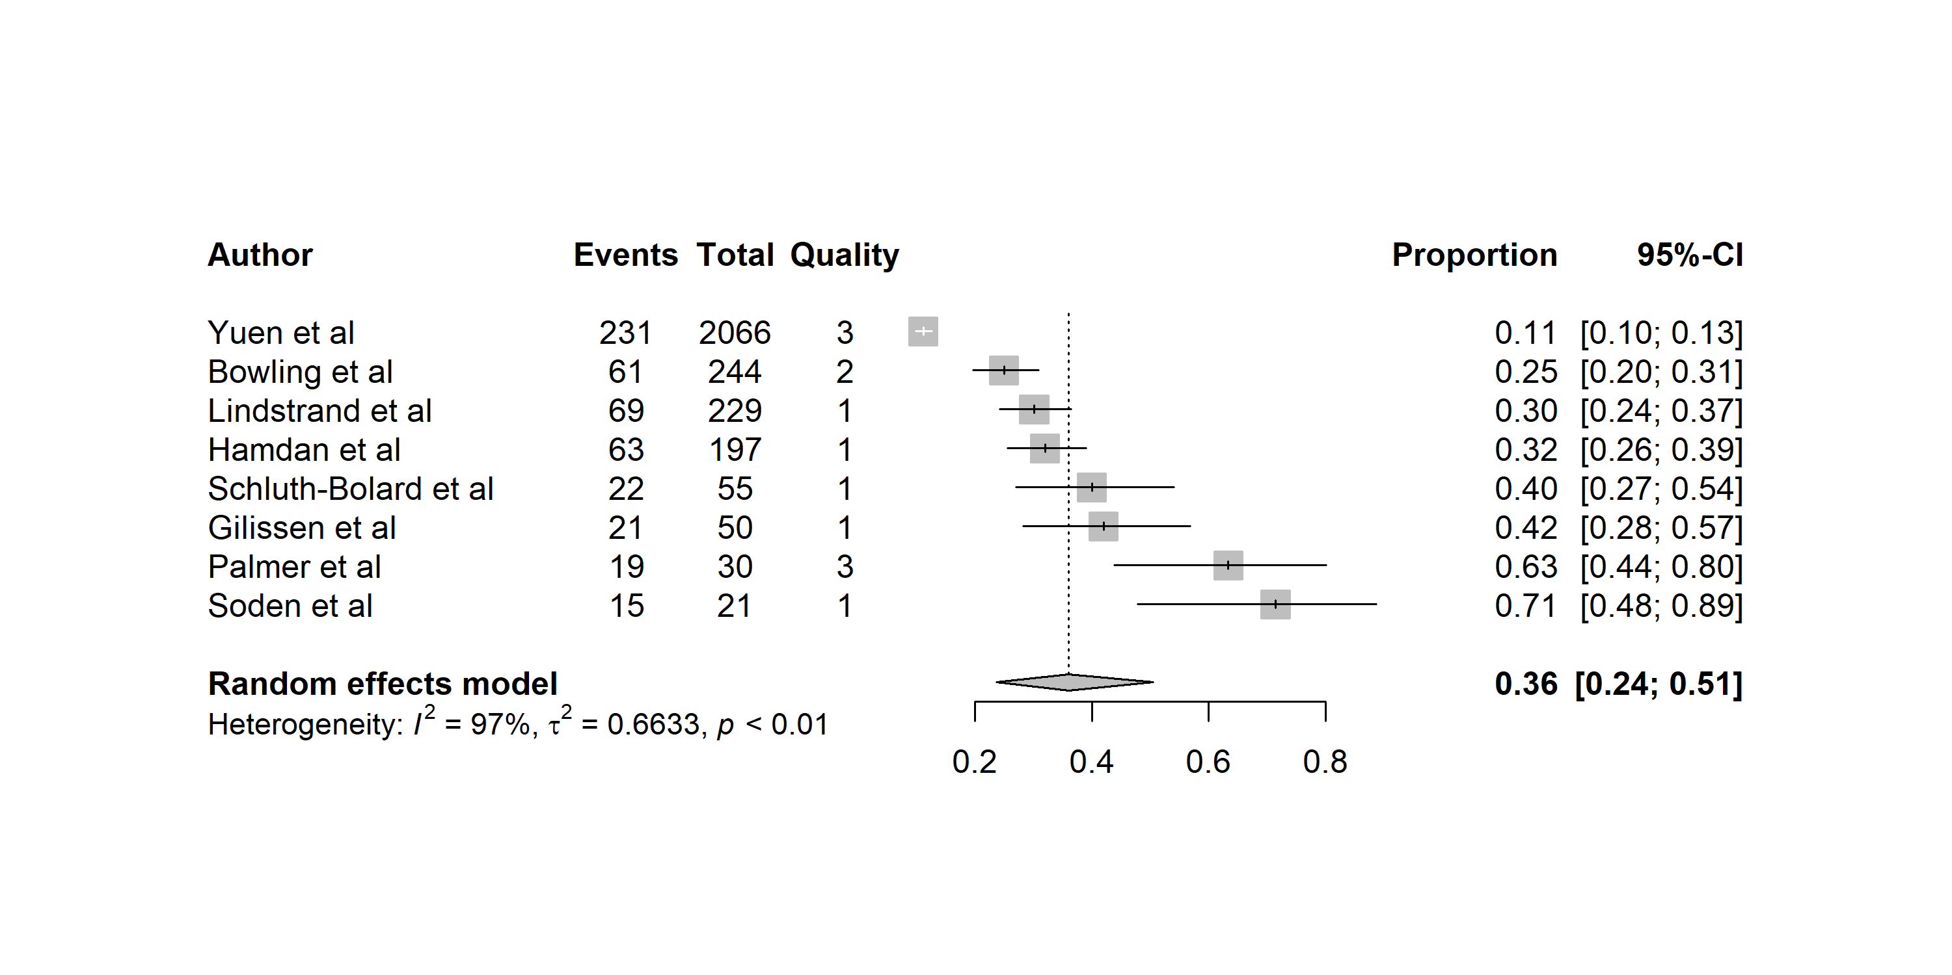

#### Other Neurological Disorders

m.prop_clin_neuro2 <- metaprop(event = Positive_test_count,  
 n = Proband_count,  
 studlab = Authors,  
 data = mgi_data %>% drop_na(Proband_count) %>%   
 filter(Phenotype_Group == "Neuro_other"),  
 method = "GLMM",  
 sm = "PLOGIT",  
 fixed = FALSE,  
 random = TRUE,  
 method.ci = "CP",  
 title = "Diagnostic Yields")  
summary(m.prop_clin_neuro2)

Review: Diagnostic Yields  
  
 proportion 95%-CI  
Kumar et al 0.4444 [0.1370; 0.7880]  
Ostrander et al 0.8571 [0.5719; 0.9822]  
Kang et al 0.3333 [0.0084; 0.9057]  
Kumar et al 0.1171 [0.0639; 0.1919]  
Helman et al 0.3415 [0.2008; 0.5059]  
Vanderver et al 0.5938 [0.4064; 0.7630]  
Zou et al 0.3656 [0.3128; 0.4210]  
  
Number of studies: k = 7  
Number of observations: o = 530  
Number of events: e = 180  
  
 proportion 95%-CI  
Random effects model 0.4138 [0.2352; 0.6183]  
  
Quantifying heterogeneity:  
 tau^2 = 0.9697; tau = 0.9847; I^2 = 85.3% [71.7%; 92.4%]; H = 2.61 [1.88; 3.63]  
  
Test of heterogeneity:  
 Q d.f. p-value  
 Wald 40.88 6 < 0.0001  
 LRT 55.30 6 < 0.0001  
  
Details on meta-analytical method:  
- Random intercept logistic regression model  
- Maximum-likelihood estimator for tau^2  
- Logit transformation  
- Clopper-Pearson confidence interval for individual studies

png(file = "forestplot_phen_neuro_other.png", width = 3000, height = 2000, res = 300)  
forest.meta(m.prop_clin_neuro2,   
 sortvar = DY_percent,   
 leftcols = c("Authors", "Positive_test_count", "Proband_count", "ACR_FINAL"),  
 leftlabs = c("Author", "Events", "Total", "Quality"))  
dev.off()

png   
 2

knitr::include_graphics('./forestplot_phen_neuro_other.png')

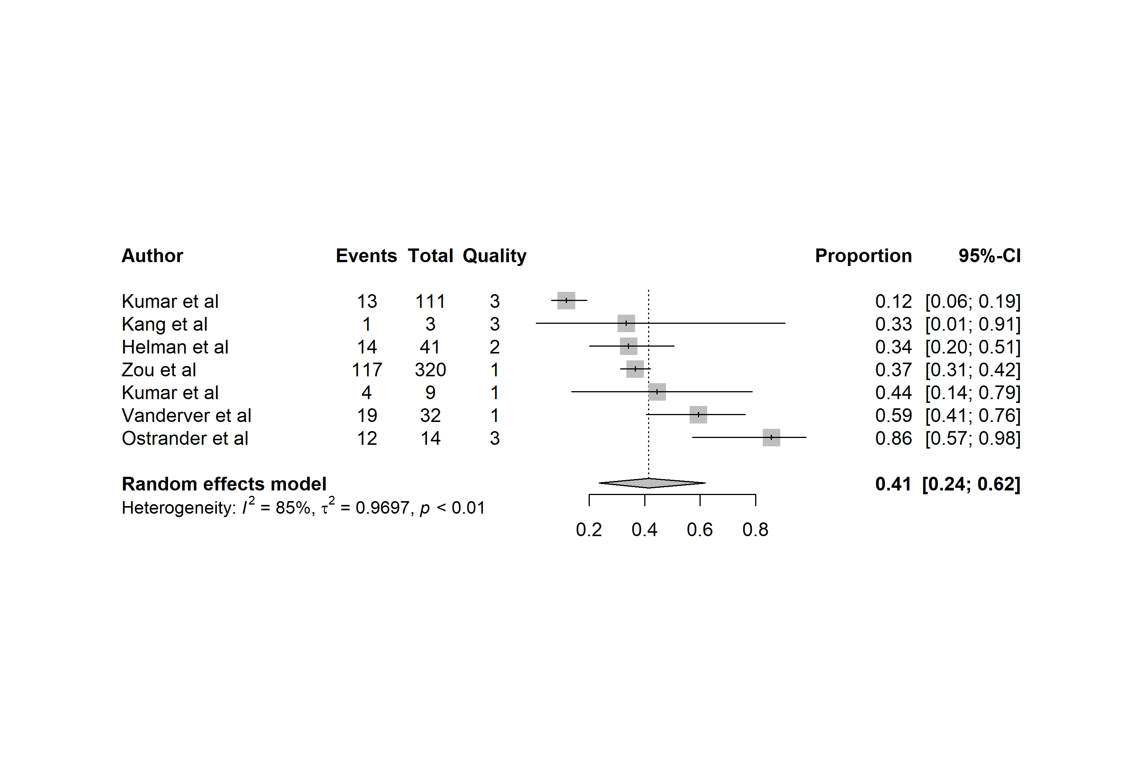

#### Cardiomyopathy

m.prop_clin_card <- metaprop(event = Positive_test_count,  
 n = Proband_count,  
 studlab = Authors,  
 data = mgi_data %>% drop_na(Proband_count) %>%   
 filter(Phenotype_Group == "Cardiomyopathy"),  
 method = "GLMM",  
 sm = "PLOGIT",  
 fixed = FALSE,  
 random = TRUE,  
 method.ci = "CP",  
 title = "Diagnostic Yields")  
summary(m.prop_clin_card)

Review: Diagnostic Yields  
  
 proportion 95%-CI  
Cirino et al 0.3415 [0.2008; 0.5059]  
Bagnall et al 0.2414 [0.1387; 0.3717]  
Minoche et al 0.5714 [0.4096; 0.7228]  
Al-Hassnan et al 0.5366 [0.4658; 0.6063]  
Lesurf et al 0.3923 [0.3257; 0.4621]  
  
Number of studies: k = 5  
Number of observations: o = 555  
Number of events: e = 244  
  
 proportion 95%-CI  
Random effects model 0.4159 [0.3139; 0.5257]  
  
Quantifying heterogeneity:  
 tau^2 = 0.1935; tau = 0.4398; I^2 = 82.4% [59.5%; 92.3%]; H = 2.38 [1.57; 3.61]  
  
Test of heterogeneity:  
 Q d.f. p-value  
 Wald 22.70 4 0.0001  
 LRT 24.11 4 < 0.0001  
  
Details on meta-analytical method:  
- Random intercept logistic regression model  
- Maximum-likelihood estimator for tau^2  
- Logit transformation  
- Clopper-Pearson confidence interval for individual studies

png(file = "forestplot_phen_card.png", width = 3000, height = 2000, res = 300)  
forest.meta(m.prop_clin_card,   
 sortvar = DY_percent,   
 leftcols = c("Authors", "Positive_test_count", "Proband_count", "ACR_FINAL"),  
 leftlabs = c("Author", "Events", "Total", "Quality"))  
dev.off()

png   
 2

knitr::include_graphics('./forestplot_phen_card.png')

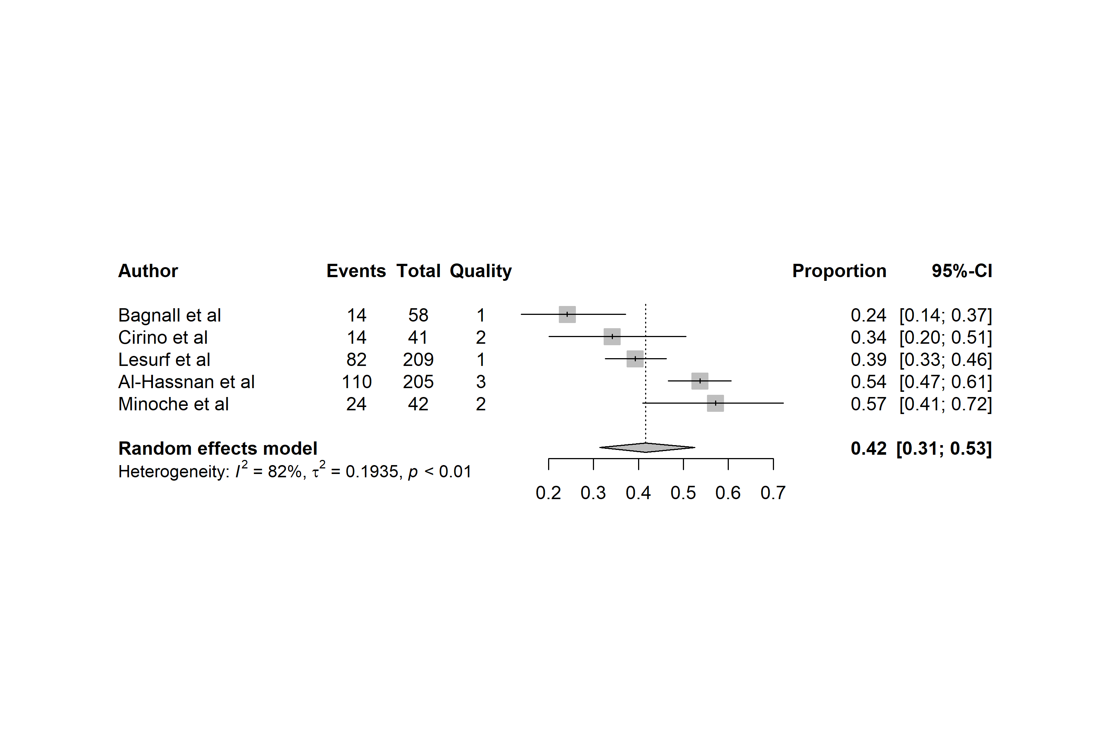

#### Ophthalmologic Disorders

m.prop_clin_ophth <- metaprop(event = Positive_test_count,  
 n = Proband_count,  
 studlab = Authors,  
 data = mgi_data %>% drop_na(Proband_count) %>%   
 filter(Phenotype_Group == "Ophthalmic"),  
 method = "GLMM",  
 sm = "PLOGIT",  
 fixed = FALSE,  
 random = TRUE,  
 method.ci = "CP",  
 title = "Diagnostic Yields")  
summary(m.prop_clin_ophth)

Review: Diagnostic Yields  
  
 proportion 95%-CI  
Ellingford et al 0.5217 [0.3695; 0.6711]  
Hull et al 0.6000 [0.1466; 0.9473]  
Dahl et al 0.1379 [0.0389; 0.3166]  
Jackson et al 0.3609 [0.3097; 0.4147]  
Chan et al 0.5833 [0.2767; 0.8483]  
  
Number of studies: k = 5  
Number of observations: o = 430  
Number of events: e = 160  
  
 proportion 95%-CI  
Random effects model 0.3989 [0.2543; 0.5635]  
  
Quantifying heterogeneity:  
 tau^2 = 0.3677; tau = 0.6064; I^2 = 70.4% [24.5%; 88.4%]; H = 1.84 [1.15; 2.93]  
  
Test of heterogeneity:  
 Q d.f. p-value  
 Wald 13.50 4 0.0091  
 LRT 15.59 4 0.0036  
  
Details on meta-analytical method:  
- Random intercept logistic regression model  
- Maximum-likelihood estimator for tau^2  
- Logit transformation  
- Clopper-Pearson confidence interval for individual studies

png(file = "forestplot_phen_ophth.png", width = 3000, height = 2000, res = 300)  
forest.meta(m.prop_clin_ophth,   
 sortvar = DY_percent,   
 leftcols = c("Authors", "Positive_test_count", "Proband_count", "ACR_FINAL"),  
 leftlabs = c("Author", "Events", "Total", "Quality"))  
dev.off()

png   
 2

knitr::include_graphics('./forestplot_phen_ophth.png')

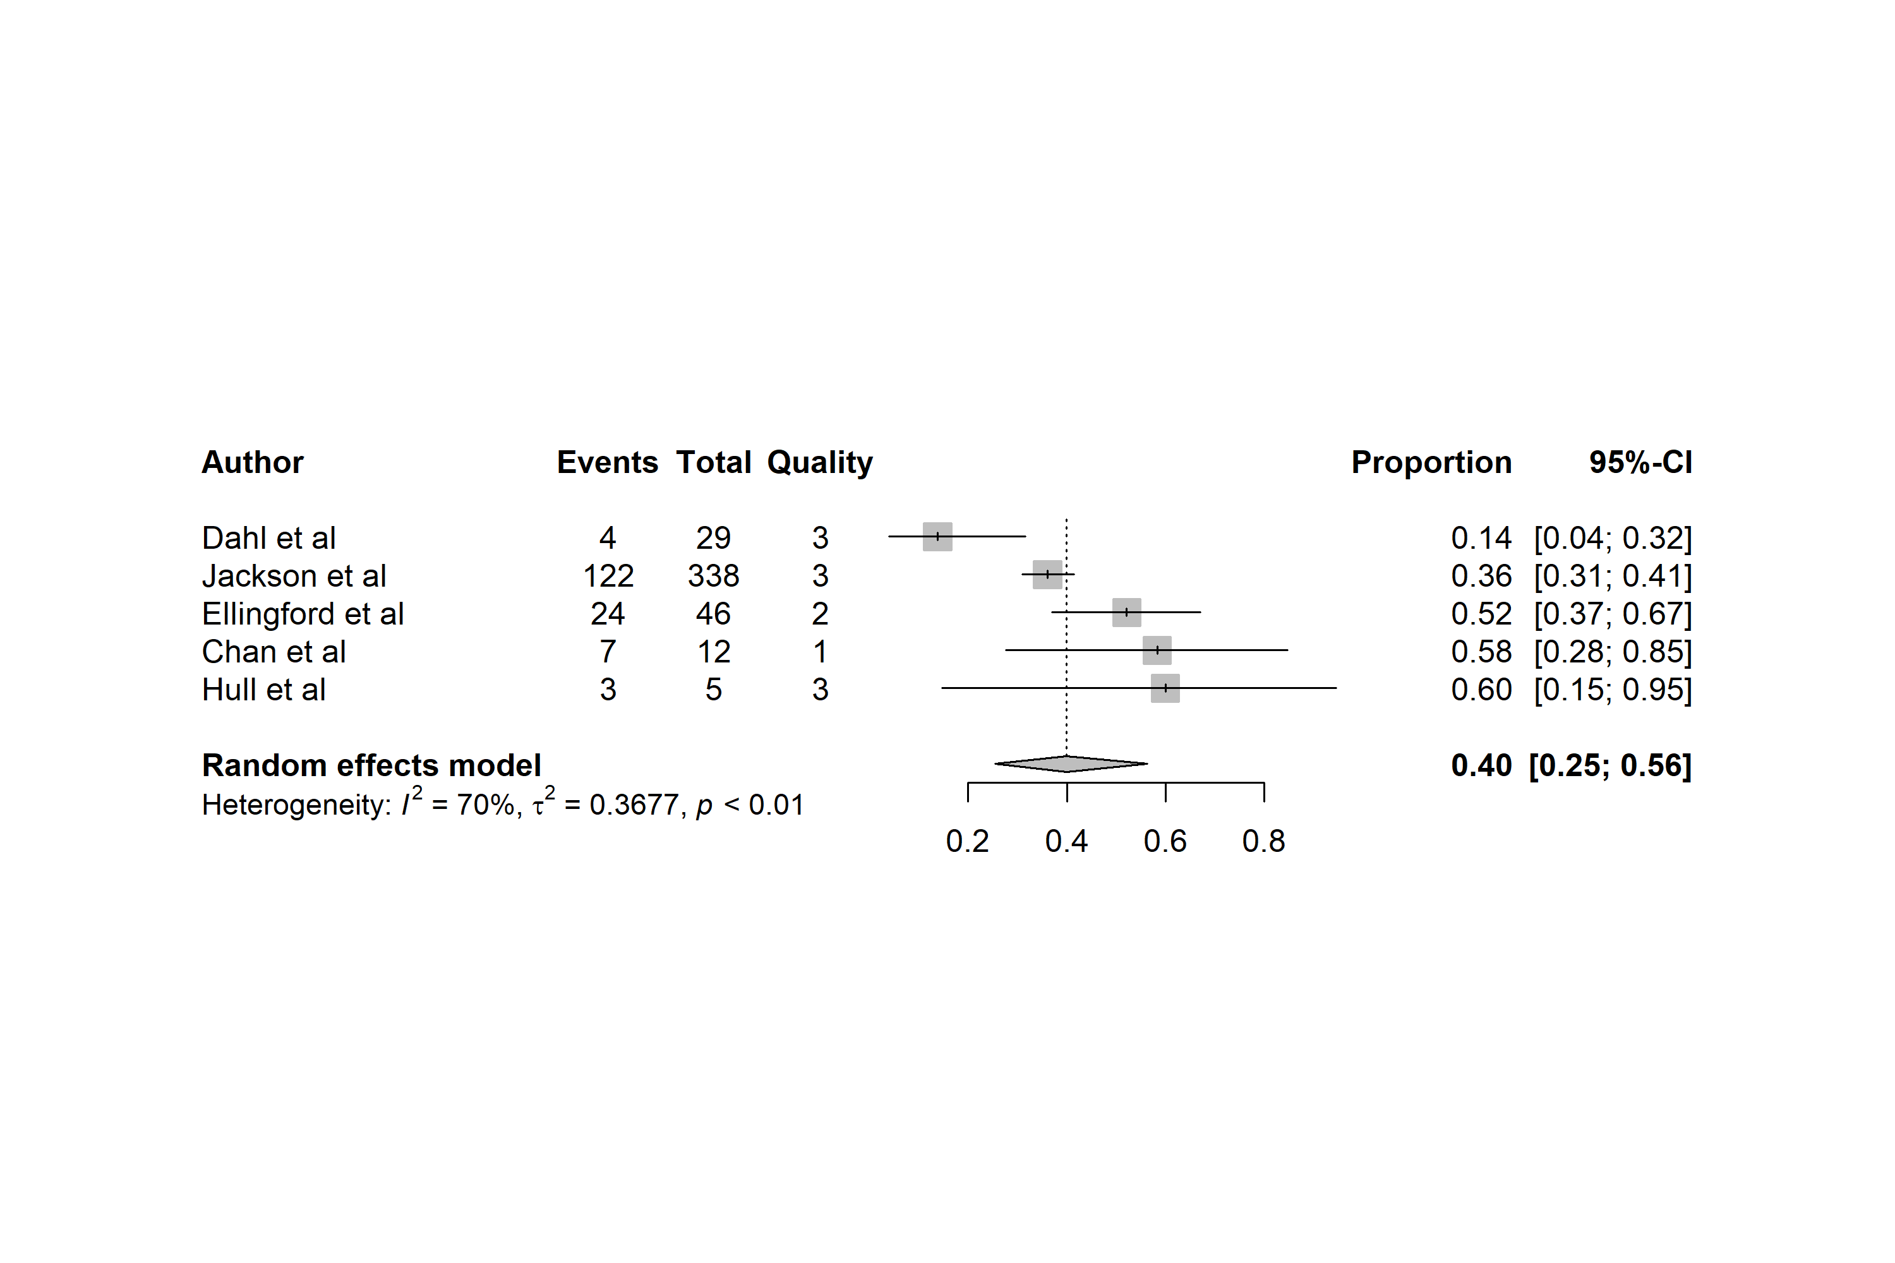

### Metaregression

#### Year

#relationship of Year to diagnostic yield  
m.gen.year <- metareg(m.prop_all, ~Year)  
summary(m.gen.year)

Mixed-Effects Model (k = 71; tau^2 estimator: ML)  
  
 logLik deviance AIC BIC AICc   
-163.7521 13.8872 333.5043 340.2923 333.8625   
  
tau^2 (estimated amount of residual heterogeneity): 0.6000  
tau (square root of estimated tau^2 value): 0.7746  
I^2 (residual heterogeneity / unaccounted variability): 95.09%  
H^2 (unaccounted variability / sampling variability): 20.35  
  
Tests for Residual Heterogeneity:  
Wld(df = 69) = 875.8573, p-val < .0001  
LRT(df = 69) = 992.3861, p-val < .0001  
  
Test of Moderators (coefficient 2):  
QM(df = 1) = 0.4549, p-val = 0.5000  
  
Model Results:  
  
 estimate se zval pval ci.lb ci.ub   
intrcpt 68.2526 102.1475 0.6682 0.5040 -131.9529 268.4581   
Year -0.0341 0.0506 -0.6745 0.5000 -0.1333 0.0650   
  
---  
Signif. codes: 0 '***' 0.001 '**' 0.01 '*' 0.05 '.' 0.1 ' ' 1

bubble(m.gen.year, studlab = F, ylim = c(-3,2))

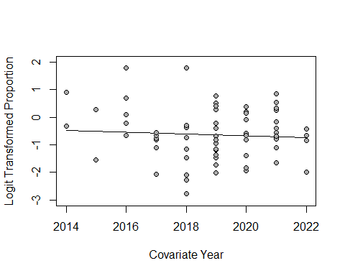

### Subgroup Meta-Analysis

Is there a difference in HCM results comparing studies that included children and those that were adult patients only

#### All Studies

#All studies by phenotype groups used for forest plots  
update.meta(m.prop_all,   
 subgroup = Phenotype_Group,   
 tau.common = FALSE)

Review: Diagnostic Yields  
  
Number of studies: k = 71  
Number of observations: o = 13913  
Number of events: e = 4214  
  
 proportion 95%-CI  
Random effects model 0.3443 [0.3012; 0.3900]  
  
Quantifying heterogeneity:  
 tau^2 = 0.6021; tau = 0.7760; I^2 = 93.0% [91.8%; 94.0%]; H = 3.77 [3.48; 4.08]  
  
Test of heterogeneity:  
 Q d.f. p-value  
 Wald 995.06 70 < 0.0001  
 LRT 1199.45 70 < 0.0001  
  
Results for subgroups (random effects model):  
 k proportion 95%-CI tau^2 tau  
Phenotype_Group = ID_DD 8 0.3600 [0.2366; 0.5052] 0.6633 0.8144  
Phenotype_Group = Heterogeneous 34 0.3091 [0.2649; 0.3571] 0.3296 0.5741  
Phenotype_Group = Ophthalmic 5 0.3989 [0.2543; 0.5635] 0.3677 0.6064  
Phenotype_Group = Neuro_other 7 0.4138 [0.2352; 0.6183] 0.9697 0.9847  
Phenotype_Group = Other 5 0.4807 [0.1898; 0.7853] 2.1251 1.4578  
Phenotype_Group = Cardiomyopathy 5 0.4159 [0.3139; 0.5257] 0.1935 0.4398  
Phenotype_Group = CHD 4 0.2028 [0.0921; 0.3896] 0.7197 0.8484  
Phenotype_Group = Mitochondrial 3 0.4516 [0.3111; 0.6003] 0.1926 0.4389  
 Q I^2  
Phenotype_Group = ID_DD 205.36 96.6%  
Phenotype_Group = Heterogeneous 302.96 89.1%  
Phenotype_Group = Ophthalmic 13.50 70.4%  
Phenotype_Group = Neuro_other 40.88 85.3%  
Phenotype_Group = Other 106.97 96.3%  
Phenotype_Group = Cardiomyopathy 22.70 82.4%  
Phenotype_Group = CHD 20.75 85.5%  
Phenotype_Group = Mitochondrial 13.87 85.6%  
  
Test for subgroup differences (random effects model):  
 Q d.f. p-value  
Between groups 10.13 7 0.1814  
  
Details on meta-analytical method:  
- Random intercept logistic regression model  
- Maximum-likelihood estimator for tau^2  
- Logit transformation

#All studies by ACR Quality  
update.meta(m.prop_all,   
 subgroup = ACR_FINAL,   
 tau.common = FALSE)

Review: Diagnostic Yields  
  
Number of studies: k = 71  
Number of observations: o = 13913  
Number of events: e = 4214  
  
 proportion 95%-CI  
Random effects model 0.3443 [0.3012; 0.3900]  
  
Quantifying heterogeneity:  
 tau^2 = 0.6021; tau = 0.7760; I^2 = 93.0% [91.8%; 94.0%]; H = 3.77 [3.48; 4.08]  
  
Test of heterogeneity:  
 Q d.f. p-value  
 Wald 995.06 70 < 0.0001  
 LRT 1199.45 70 < 0.0001  
  
Results for subgroups (random effects model):  
 k proportion 95%-CI tau^2 tau Q I^2  
ACR_FINAL = 1 39 0.3329 [0.2876; 0.3815] 0.3741 0.6116 350.44 89.2%  
ACR_FINAL = 3 16 0.3407 [0.2300; 0.4721] 1.0260 1.0129 372.60 96.0%  
ACR_FINAL = 2 16 0.3826 [0.2795; 0.4976] 0.7865 0.8869 135.76 89.0%  
  
Test for subgroup differences (random effects model):  
 Q d.f. p-value  
Between groups 0.68 2 0.7105  
  
Details on meta-analytical method:  
- Random intercept logistic regression model  
- Maximum-likelihood estimator for tau^2  
- Logit transformation

#All studies by Study Population  
update.meta(m.prop_all,   
 subgroup = Study_pop,   
 tau.common = FALSE)

Review: Diagnostic Yields  
  
Number of studies: k = 71  
Number of observations: o = 13913  
Number of events: e = 4214  
  
 proportion 95%-CI  
Random effects model 0.3443 [0.3012; 0.3900]  
  
Quantifying heterogeneity:  
 tau^2 = 0.6021; tau = 0.7760; I^2 = 93.0% [91.8%; 94.0%]; H = 3.77 [3.48; 4.08]  
  
Test of heterogeneity:  
 Q d.f. p-value  
 Wald 995.06 70 < 0.0001  
 LRT 1199.45 70 < 0.0001  
  
Results for subgroups (random effects model):  
 k proportion 95%-CI  
Study_pop = Mixed 26 0.3022 [0.2391; 0.3739]  
Study_pop = Pediatric inpatient/acute care 16 0.3530 [0.3052; 0.4039]  
Study_pop = Adult outpatient 7 0.4047 [0.2158; 0.6267]  
Study_pop = mixed 2 0.5366 [0.3853; 0.6814]  
Study_pop = Pediatric outpatient 20 0.3688 [0.2806; 0.4668]  
 tau^2 tau Q I^2  
Study_pop = Mixed 0.5909 0.7687 346.44 92.8%  
Study_pop = Pediatric inpatient/acute care 0.1248 0.3532 44.71 66.4%  
Study_pop = Adult outpatient 1.2583 1.1217 67.13 91.1%  
Study_pop = mixed 0 0 0.39 0.0%  
Study_pop = Pediatric outpatient 0.7192 0.8481 470.66 96.0%  
  
Test for subgroup differences (random effects model):  
 Q d.f. p-value  
Between groups 8.08 4 0.0888  
  
Details on meta-analytical method:  
- Random intercept logistic regression model  
- Maximum-likelihood estimator for tau^2  
- Logit transformation

#All studies and prior testing  
update.meta(m.prop_all,   
 subgroup = Prior_testing,   
 tau.common = FALSE)

Review: Diagnostic Yields  
  
Number of studies: k = 71  
Number of observations: o = 13913  
Number of events: e = 4214  
  
 proportion 95%-CI  
Random effects model 0.3443 [0.3012; 0.3900]  
  
Quantifying heterogeneity:  
 tau^2 = 0.6021; tau = 0.7760; I^2 = 93.0% [91.8%; 94.0%]; H = 3.77 [3.48; 4.08]  
  
Test of heterogeneity:  
 Q d.f. p-value  
 Wald 995.06 70 < 0.0001  
 LRT 1199.45 70 < 0.0001  
  
Results for subgroups (random effects model):  
 k proportion  
Prior_testing = Exome-negative cohort (>80%) 8 0.2807  
Prior_testing = First-tier test / genetic testi ... 27 0.4335  
Prior_testing = Some genetic tests (exome seque ... 36 0.2928  
 95%-CI tau^2  
Prior_testing = Exome-negative cohort (>80%) [0.1909; 0.3922] 0.3477  
Prior_testing = First-tier test / genetic testi ... [0.3668; 0.5026] 0.4468  
Prior_testing = Some genetic tests (exome seque ... [0.2402; 0.3514] 0.5647  
 tau Q I^2  
Prior_testing = Exome-negative cohort (>80%) 0.5896 28.29 75.3%  
Prior_testing = First-tier test / genetic testi ... 0.6685 186.73 86.1%  
Prior_testing = Some genetic tests (exome seque ... 0.7515 671.76 94.8%  
  
Test for subgroup differences (random effects model):  
 Q d.f. p-value  
Between groups 11.34 2 0.0034  
  
Details on meta-analytical method:  
- Random intercept logistic regression model  
- Maximum-likelihood estimator for tau^2  
- Logit transformation

#All studies and study design - FLAGGED  
update.meta(m.prop_all,   
 subgroup = Study_design,   
 tau.common = FALSE)

Review: Diagnostic Yields  
  
Number of studies: k = 71  
Number of observations: o = 13913  
Number of events: e = 4214  
  
 proportion 95%-CI  
Random effects model 0.3443 [0.3012; 0.3900]  
  
Quantifying heterogeneity:  
 tau^2 = 0.6021; tau = 0.7760; I^2 = 93.0% [91.8%; 94.0%]; H = 3.77 [3.48; 4.08]  
  
Test of heterogeneity:  
 Q d.f. p-value  
 Wald 995.06 70 < 0.0001  
 LRT 1199.45 70 < 0.0001  
  
Results for subgroups (random effects model):  
 k proportion 95%-CI  
Study_design = Prospective, single center 35 0.3761 [0.3036; 0.4547]  
Study_design = Retrospective 14 0.3501 [0.2639; 0.4474]  
Study_design = Prospective, multi-center 15 0.2855 [0.2235; 0.3568]  
Study_design = Clinical trial 7 0.3087 [0.2330; 0.3962]  
 tau^2 tau Q I^2  
Study_design = Prospective, single center 0.8231 0.9072 319.35 89.4%  
Study_design = Retrospective 0.4717 0.6868 190.94 93.2%  
Study_design = Prospective, multi-center 0.3355 0.5792 276.17 94.9%  
Study_design = Clinical trial 0.1985 0.4455 23.48 74.4%  
  
Test for subgroup differences (random effects model):  
 Q d.f. p-value  
Between groups 3.48 3 0.3228  
  
Details on meta-analytical method:  
- Random intercept logistic regression model  
- Maximum-likelihood estimator for tau^2  
- Logit transformation

#All studies and testing strategy  
update.meta(m.prop_all,   
 subgroup = Testing_strategy,   
 tau.common = FALSE)

Review: Diagnostic Yields  
  
Number of studies: k = 71  
Number of observations: o = 13913  
Number of events: e = 4214  
  
 proportion 95%-CI  
Random effects model 0.3443 [0.3012; 0.3900]  
  
Quantifying heterogeneity:  
 tau^2 = 0.6021; tau = 0.7760; I^2 = 93.0% [91.8%; 94.0%]; H = 3.77 [3.48; 4.08]  
  
Test of heterogeneity:  
 Q d.f. p-value  
 Wald 995.06 70 < 0.0001  
 LRT 1199.45 70 < 0.0001  
  
Results for subgroups (random effects model):  
 k proportion 95%-CI  
Testing_strategy = Trio (e.g., child-parentS) 27 0.3740 [0.2975; 0.4574]  
Testing_strategy = Proband only 22 0.3359 [0.2510; 0.4328]  
Testing_strategy = Mixed 22 0.3115 [0.2638; 0.3635]  
 tau^2 tau Q I^2  
Testing_strategy = Trio (e.g., child-parentS) 0.6900 0.8307 441.75 94.1%  
Testing_strategy = Proband only 0.8524 0.9232 240.72 91.3%  
Testing_strategy = Mixed 0.2248 0.4741 117.70 82.2%  
  
Test for subgroup differences (random effects model):  
 Q d.f. p-value  
Between groups 1.73 2 0.4210  
  
Details on meta-analytical method:  
- Random intercept logistic regression model  
- Maximum-likelihood estimator for tau^2  
- Logit transformation

#All studies and Panel_disease_genes  
update.meta(m.prop_all,   
 subgroup = Panel_disease_genes,   
 tau.common = FALSE)

Review: Diagnostic Yields  
  
Number of studies: k = 71  
Number of observations: o = 13913  
Number of events: e = 4214  
  
 proportion 95%-CI  
Random effects model 0.3443 [0.3012; 0.3900]  
  
Quantifying heterogeneity:  
 tau^2 = 0.6021; tau = 0.7760; I^2 = 93.0% [91.8%; 94.0%]; H = 3.77 [3.48; 4.08]  
  
Test of heterogeneity:  
 Q d.f. p-value  
 Wald 995.06 70 < 0.0001  
 LRT 1199.45 70 < 0.0001  
  
Results for subgroups (random effects model):  
 k proportion 95%-CI tau^2 tau Q  
Panel_disease_genes = Y 30 0.3888 [0.3103; 0.4734] 0.7894 0.8885 388.56  
Panel_disease_genes = N 41 0.3155 [0.2685; 0.3666] 0.4524 0.6726 501.68  
 I^2  
Panel_disease_genes = Y 92.5%  
Panel_disease_genes = N 92.0%  
  
Test for subgroup differences (random effects model):  
 Q d.f. p-value  
Between groups 2.32 1 0.1276  
  
Details on meta-analytical method:  
- Random intercept logistic regression model  
- Maximum-likelihood estimator for tau^2  
- Logit transformation

#All studies and Initial_untargeted_analysis  
update.meta(m.prop_all,   
 subgroup = Initial_untargeted_analysis,   
 tau.common = FALSE)

Review: Diagnostic Yields  
  
Number of studies: k = 71  
Number of observations: o = 13913  
Number of events: e = 4214  
  
 proportion 95%-CI  
Random effects model 0.3443 [0.3012; 0.3900]  
  
Quantifying heterogeneity:  
 tau^2 = 0.6021; tau = 0.7760; I^2 = 93.0% [91.8%; 94.0%]; H = 3.77 [3.48; 4.08]  
  
Test of heterogeneity:  
 Q d.f. p-value  
 Wald 995.06 70 < 0.0001  
 LRT 1199.45 70 < 0.0001  
  
Results for subgroups (random effects model):  
 k proportion 95%-CI tau^2 tau  
Initial_untargeted_analysis = N 30 0.3888 [0.3103; 0.4734] 0.7894 0.8885  
Initial_untargeted_analysis = Y 41 0.3155 [0.2685; 0.3666] 0.4524 0.6726  
 Q I^2  
Initial_untargeted_analysis = N 388.56 92.5%  
Initial_untargeted_analysis = Y 501.68 92.0%  
  
Test for subgroup differences (random effects model):  
 Q d.f. p-value  
Between groups 2.32 1 0.1276  
  
Details on meta-analytical method:  
- Random intercept logistic regression model  
- Maximum-likelihood estimator for tau^2  
- Logit transformation

#All studies and Untargeted_analysis  
update.meta(m.prop_all,   
 subgroup = Untargeted_analysis,   
 tau.common = FALSE)

Review: Diagnostic Yields  
  
Number of studies: k = 71  
Number of observations: o = 13913  
Number of events: e = 4214  
  
 proportion 95%-CI  
Random effects model 0.3443 [0.3012; 0.3900]  
  
Quantifying heterogeneity:  
 tau^2 = 0.6021; tau = 0.7760; I^2 = 93.0% [91.8%; 94.0%]; H = 3.77 [3.48; 4.08]  
  
Test of heterogeneity:  
 Q d.f. p-value  
 Wald 995.06 70 < 0.0001  
 LRT 1199.45 70 < 0.0001  
  
Results for subgroups (random effects model):  
 k proportion 95%-CI tau^2 tau Q  
Untargeted_analysis = Y 57 0.3267 [0.2843; 0.3720] 0.4935 0.7025 744.45  
Untargeted_analysis = N 14 0.4382 [0.2963; 0.5910] 1.1458 1.0704 94.75  
 I^2  
Untargeted_analysis = Y 92.5%  
Untargeted_analysis = N 86.3%  
  
Test for subgroup differences (random effects model):  
 Q d.f. p-value  
Between groups 2.06 1 0.1508  
  
Details on meta-analytical method:  
- Random intercept logistic regression model  
- Maximum-likelihood estimator for tau^2  
- Logit transformation

#All studies and noncoding_analysis  
update.meta(m.prop_all,   
 subgroup = noncoding_analysis,   
 tau.common = FALSE)

Review: Diagnostic Yields  
  
Number of studies: k = 71  
Number of observations: o = 13913  
Number of events: e = 4214  
  
 proportion 95%-CI  
Random effects model 0.3443 [0.3012; 0.3900]  
  
Quantifying heterogeneity:  
 tau^2 = 0.6021; tau = 0.7760; I^2 = 93.0% [91.8%; 94.0%]; H = 3.77 [3.48; 4.08]  
  
Test of heterogeneity:  
 Q d.f. p-value  
 Wald 995.06 70 < 0.0001  
 LRT 1199.45 70 < 0.0001  
  
Results for subgroups (random effects model):  
 k proportion 95%-CI tau^2 tau Q  
noncoding_analysis = Y 35 0.3323 [0.2791; 0.3902] 0.4852 0.6965 374.01  
noncoding_analysis = N 36 0.3566 [0.2899; 0.4294] 0.7278 0.8531 565.24  
 I^2  
noncoding_analysis = Y 90.9%  
noncoding_analysis = N 93.8%  
  
Test for subgroup differences (random effects model):  
 Q d.f. p-value  
Between groups 0.28 1 0.5938  
  
Details on meta-analytical method:  
- Random intercept logistic regression model  
- Maximum-likelihood estimator for tau^2  
- Logit transformation

#All studies and SV_dx  
update.meta(m.prop_all,   
 subgroup = SV_dx,   
 tau.common = FALSE)

Review: Diagnostic Yields  
  
Number of studies: k = 71  
Number of observations: o = 13913  
Number of events: e = 4214  
  
 proportion 95%-CI  
Random effects model 0.3443 [0.3012; 0.3900]  
  
Quantifying heterogeneity:  
 tau^2 = 0.6021; tau = 0.7760; I^2 = 93.0% [91.8%; 94.0%]; H = 3.77 [3.48; 4.08]  
  
Test of heterogeneity:  
 Q d.f. p-value  
 Wald 995.06 70 < 0.0001  
 LRT 1199.45 70 < 0.0001  
  
Results for subgroups (random effects model):  
 k proportion 95%-CI tau^2 tau Q I^2  
SV_dx = N 47 0.3247 [0.2756; 0.3780] 0.5457 0.7387 575.31 92.0%  
SV_dx = Y 24 0.3827 [0.3038; 0.4684] 0.6705 0.8188 363.85 93.7%  
  
Test for subgroup differences (random effects model):  
 Q d.f. p-value  
Between groups 1.39 1 0.2379  
  
Details on meta-analytical method:  
- Random intercept logistic regression model  
- Maximum-likelihood estimator for tau^2  
- Logit transformation

#All studies and STR_dx  
update.meta(m.prop_all,   
 subgroup = STR_dx,   
 tau.common = FALSE)

Review: Diagnostic Yields  
  
Number of studies: k = 71  
Number of observations: o = 13913  
Number of events: e = 4214  
  
 proportion 95%-CI  
Random effects model 0.3443 [0.3012; 0.3900]  
  
Quantifying heterogeneity:  
 tau^2 = 0.6021; tau = 0.7760; I^2 = 93.0% [91.8%; 94.0%]; H = 3.77 [3.48; 4.08]  
  
Test of heterogeneity:  
 Q d.f. p-value  
 Wald 995.06 70 < 0.0001  
 LRT 1199.45 70 < 0.0001  
  
Results for subgroups (random effects model):  
 k proportion 95%-CI tau^2 tau Q I^2  
STR_dx = N 61 0.3558 [0.3072; 0.4076] 0.6383 0.7990 804.85 92.5%  
STR_dx = Y 10 0.2840 [0.2153; 0.3645] 0.2936 0.5418 171.93 94.8%  
  
Test for subgroup differences (random effects model):  
 Q d.f. p-value  
Between groups 2.29 1 0.1306  
  
Details on meta-analytical method:  
- Random intercept logistic regression model  
- Maximum-likelihood estimator for tau^2  
- Logit transformation

#All studies and testing strategy  
update.meta(m.prop_all,   
 subgroup = Mito_dx,   
 tau.common = FALSE)

Review: Diagnostic Yields  
  
Number of studies: k = 71  
Number of observations: o = 13913  
Number of events: e = 4214  
  
 proportion 95%-CI  
Random effects model 0.3443 [0.3012; 0.3900]  
  
Quantifying heterogeneity:  
 tau^2 = 0.6021; tau = 0.7760; I^2 = 93.0% [91.8%; 94.0%]; H = 3.77 [3.48; 4.08]  
  
Test of heterogeneity:  
 Q d.f. p-value  
 Wald 995.06 70 < 0.0001  
 LRT 1199.45 70 < 0.0001  
  
Results for subgroups (random effects model):  
 k proportion 95%-CI tau^2 tau Q I^2  
Mito_dx = N 57 0.3326 [0.2833; 0.3858] 0.6648 0.8153 767.10 92.7%  
Mito_dx = Y 14 0.3856 [0.3100; 0.4671] 0.3290 0.5736 193.37 93.3%  
  
Test for subgroup differences (random effects model):  
 Q d.f. p-value  
Between groups 1.24 1 0.2663  
  
Details on meta-analytical method:  
- Random intercept logistic regression model  
- Maximum-likelihood estimator for tau^2  
- Logit transformation

#### Bubble Plot

theme_set(theme_minimal())  
ggplot(data = mgi_data, aes(x = Phenotype_Group, y = DY_percent, color = Prior_testing, fill = Prior_testing, size = Proband_count)) + geom_jitter(width = .1, height = 0) + scale_color_manual(values=c("#c9aa57ff", "#e87157ff", "#5e6aa4ff")) + theme(axis.text.x = element_text(angle = 45))

